Ex10-Create a simple cloud software application for online super market using any Cloud Service Provider to demonstrate SaaS with the template of customer name, address, phone, email, items, quantity etc. with the item classification form.

PROCEDURE:  
Step 1: create a new application for online supermarket

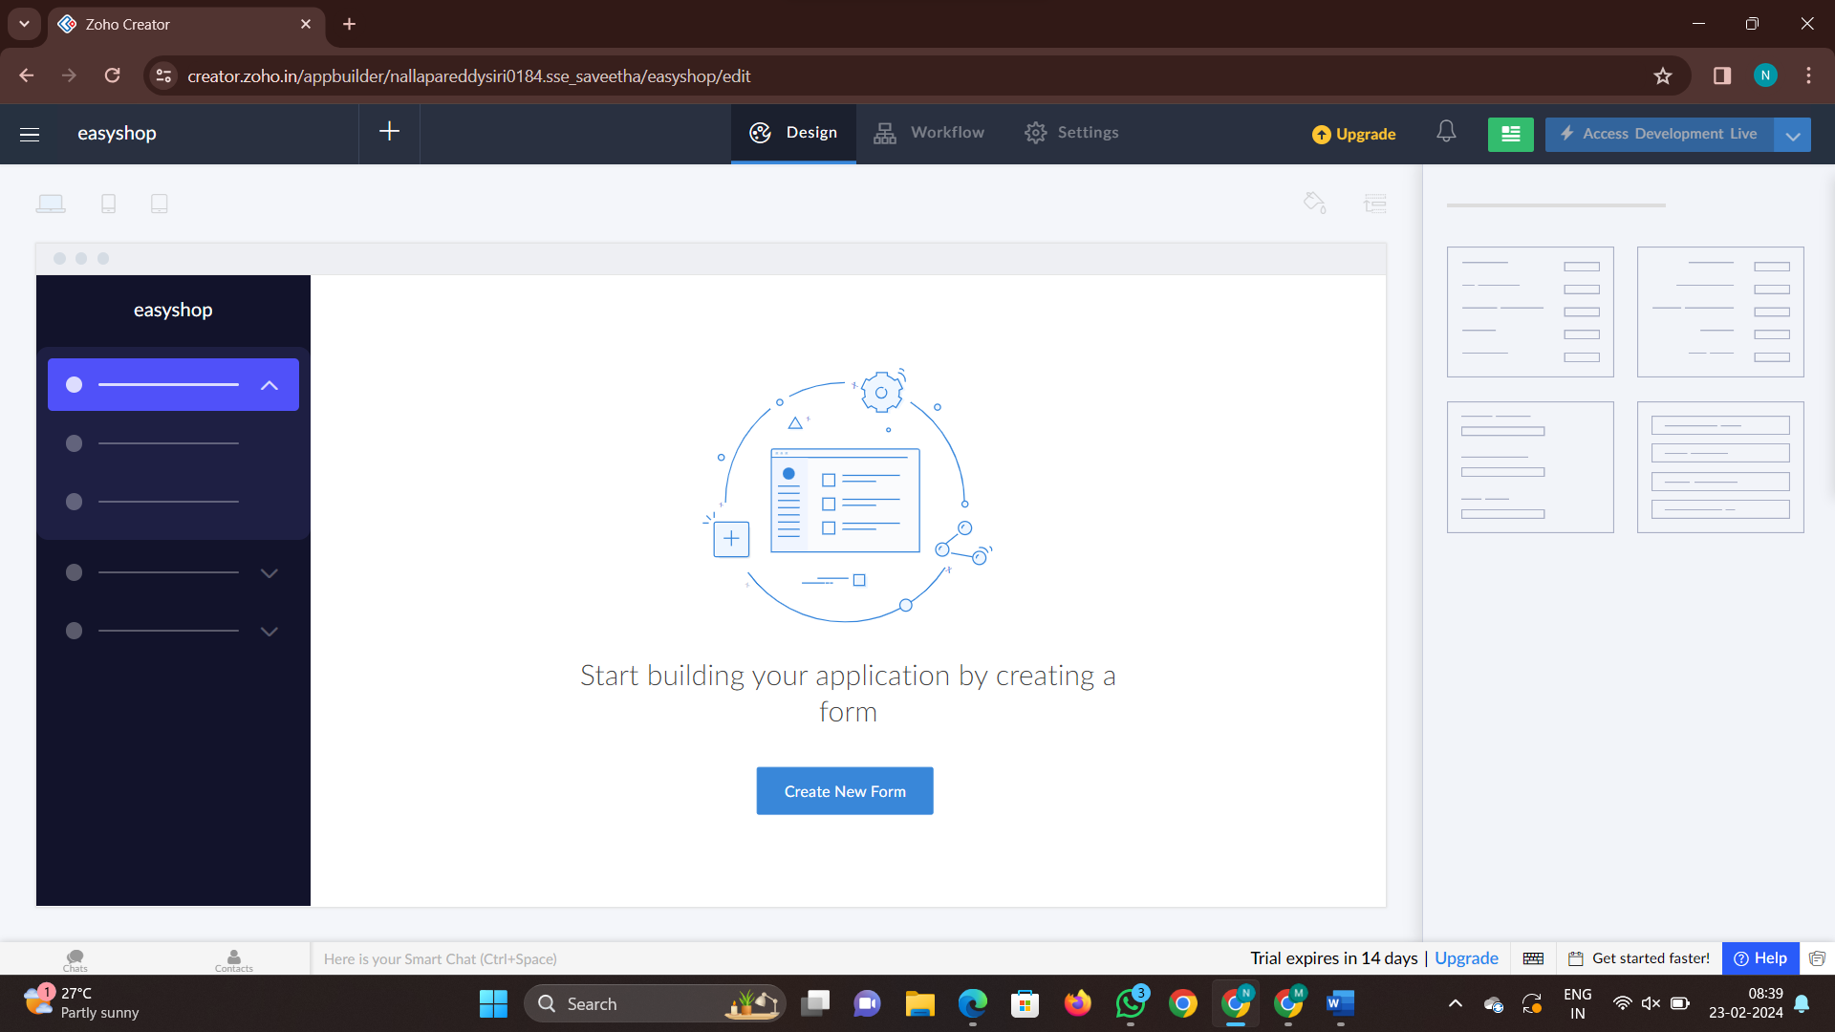

Step 2: create a new form as customer details

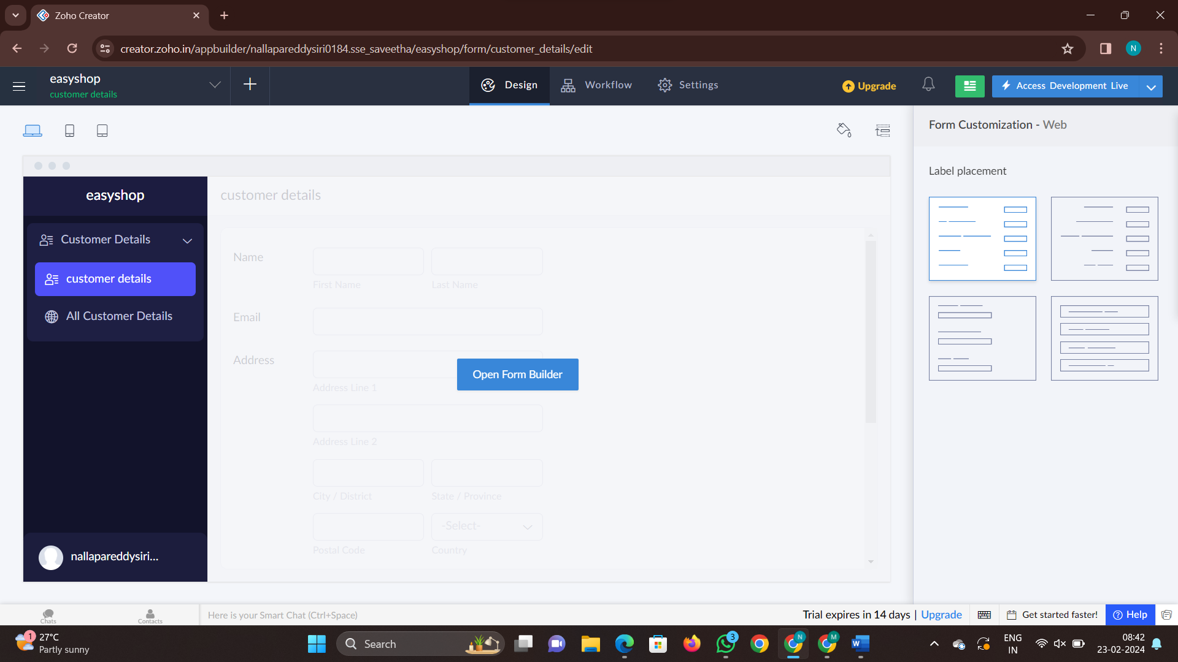

Step 3: add new form to fill the details

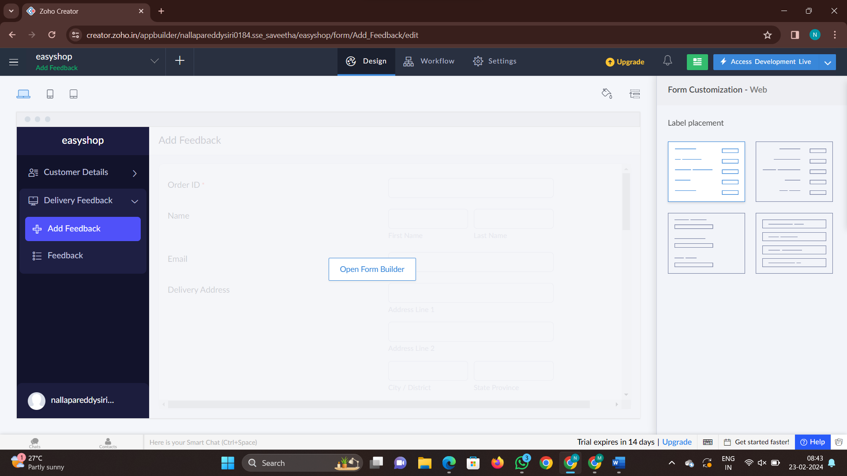

Step 4:add another form to track the order

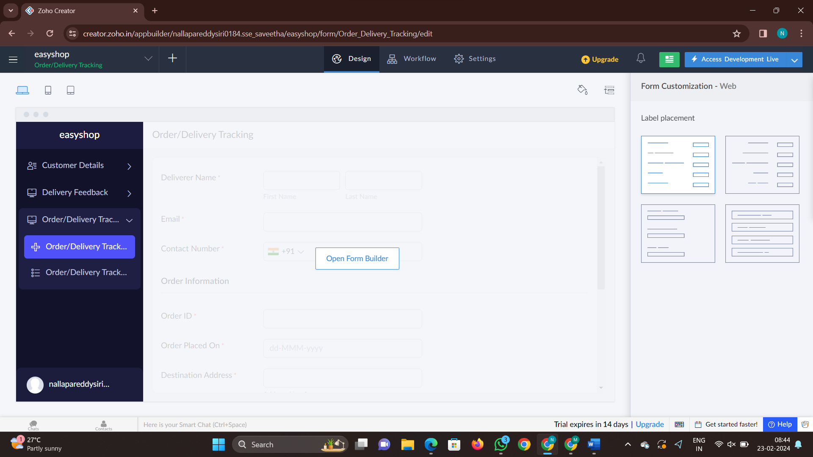

Step 5:click on access development live and fill the details

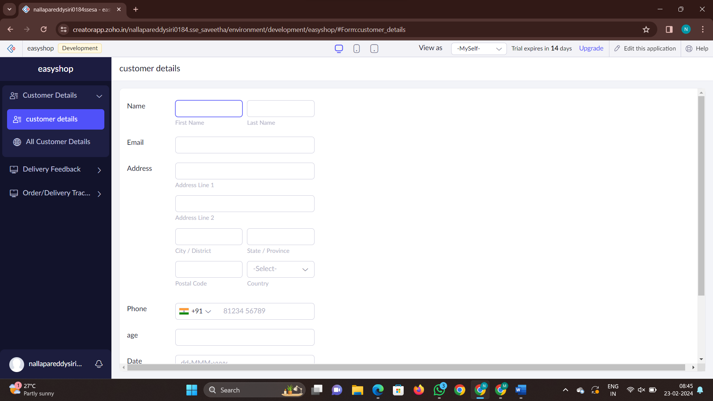

Step 6: fill the details and check the report

